I can compare text features

|  |  |  |
| --- | --- | --- |
| Rate yourself | Atlas book.JPG | Australia pic.JPG |
| Illustrations |  |  |
| Words/Text  (labels, sentences, captions) |  |  |
| Length of selection |  |  |

I can compare text features

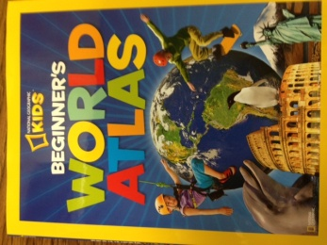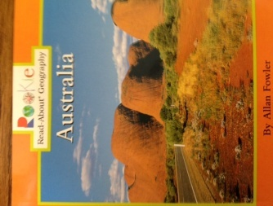

Same Different